# CIS7 Unit 6 In-Class Assignment: Probability

Refer to class note and textbook Chapter 9 to solve the following problems.

1. When using a pair of dice, red and black, what is the sample space?

Sample Space = 6 * 6 = 36

1. Using the same pair of dice in Exercise 1.
2. How many ways can you roll the dice to yield 7?

| Color |  |  |  |  |  |  |
| --- | --- | --- | --- | --- | --- | --- |
| Red | **1** | **2** | **3** | **4** | **5** | **6** |
| Black | **6** | **5** | **4** | **3** | **2** | **1** |

1. What is the probability of rolling a sum of 7 with the pair of dice?

Probability = $\frac{6}{36}=\frac{1}{6}$

1. What is the probability of rolling a sum of less than 7 with a pair of dice?

Sum = 6,5,4,3,2

| Color |  |  |  |  |  |  |
| --- | --- | --- | --- | --- | --- | --- |
| Red | **1** | **2** | **3** | **4** | **5** |  |
| Black | **5** | **4** | **3** | **2** | **1** |  |

Sum of 6 = 5/36

Sum of 5 = 4/36 = 1/9

Sum of 4 = 3/36 = 1/12

Sum of 3 = 2/36 = 1/18

Sum of 2 = 1/36

Probability of rolling Sum less than 7 with a pair of dice = $\frac{5+4+3+2+1}{36}=\frac{15}{36}=\frac{5}{12}$

1. What is the probability of rolling dice to result a Snake eye? 1 on each dice.

Probability of Snake eye = $\frac{1}{36}$

1. What is the probability of red dice has a higher result than the black dice?

| Color |  |  |  |  |  |
| --- | --- | --- | --- | --- | --- |
| Red | **2** | **3** | **4** | **5** | **6** |
| Black | **1** | **1,2** | **1,2,3** | **1,2,3,4** | **1,2,3,4,5** |
| Total | **1** | **2** | **3** | **4** | **5** |

Probability of red dice having higher result than black dice = $\frac{1+2+3+4+5}{36}=\frac{15}{36}=\frac{5}{12}$

1. What is the probability of rolling even on both dice?

| Color | Roll | Roll | Roll | Roll | Roll | Roll | Roll | Roll | Roll |
| --- | --- | --- | --- | --- | --- | --- | --- | --- | --- |
| Red | **2** | **2** | **2** | **4** | **4** | **4** | **6** | **6** | **6** |
| Black | **2** | **4** | **6** | **2** | **4** | **6** | **2** | **4** | **6** |

Probability of rolling even on both dice = $\frac{9}{36}=\frac{1}{4}$

1. If a single card is drawn from a standard deck of 52 cards, what is the probability of each of these events?
2. The card is a Queen
$$\frac{4}{52}=\frac{1}{13}$$

3. The card is a red face card.
$$\frac{6}{52}=\frac{3}{26}$$

4. The card has the same suit
$$\frac{13}{52}=\frac{1}{4}$$

5. The card is an even number.

Per Suit $\frac{5}{13}$

All Suits $\frac{20}{52}$

1. Ten balls numbered 1 to 10 are in a bag.
2. What is the probability of drawing the ball numbered 8 on a single draw?
$$\frac{1}{10}$$

3. What is the probability of drawing the ball numbered 8 in three draws if: The ball drawn is always returned to the bag before the next selection?
$$\frac{10^{3}-9^{3}}{10^{3}}=\frac{271}{1000}$$

4. What is the probability of drawing the ball numbered 8 in three draws if: The balls are not returned to the bag before the next selection?
$$\frac{\left(10*9*8\right)-(9*8*7)}{(10*9*8)}=\frac{720-504}{720}=\frac{216}{720}=\frac{3}{10}$$

5. What is the probability of drawing the numbers 9, 5, 2 in any order in three draws if: The ball drawn is always returned to the bag before the next selection?

Outcomes = 952, 925, 592, 529, 295, 259

Probability = $\frac{6}{1000}$

1. What is the probability of drawing the numbers 9, 5, 2 in any order in three draws if: The balls are not returned to the bag before the next selection?

Probability = $\frac{6}{10*9*8}=\frac{6}{720}=\frac{1}{120}$

1. Create a tree diagram for a TV manufacturing to determine the probability of a random selection:

A TV manufacturer has three factories Site 1, Site 2, and Site 3 which produce 50%, 25%, and 25%, respectively, of televisions. 70% of the screens produced in Site 1 are LED televisions, 25% of those produced in Site B are LED televisions, and 25% of the televisions produced in Site 3 are LED televisions. If a television produced by the manufacturer is selected at random, calculate the probability that the selection will be a LED television.”

LED: 0.7

Other: 0.3

Site 1: 0.5

LED: 0.25

Site 2: 0.25

Other: 0.75

Site 3: 0.25

LED: 0.25

Other: 0.75

Site 1 LED = $(0.5*0.7)=$ 0.35

Site 2 LED = $(0.25*0.25)=$ 0.0625

Site 3 LED = $(0.25*0.25)=$ 0.0625

1. (Optional) Travelers in Hawaii:

Once visitors arrive at Honolulu, Oahu, they want to enjoy the sun and beaches on 2 popular neighboring islands: Maui and Kauai.

When on Oahu, 70% of tourists plan to go to Maui, 20% to Kauai, and only 10% remain on shore the next day.

When on Maui, 40% continue to stay on Maui, 50% plan to go to Kauai, and only 10% return to Oahu the next day.

Finally, when on Kauai Island, 30% prolong their stay here, 30% divert to Maui, and 40% go back to Honolulu, Oahu the next day.

Starting from Oahu, what is the probability (in percentage) that the travelers will be on the Oahu at the end of a 3-day trip? Provide transition matrix (1-step) and 3-step transition matrix.

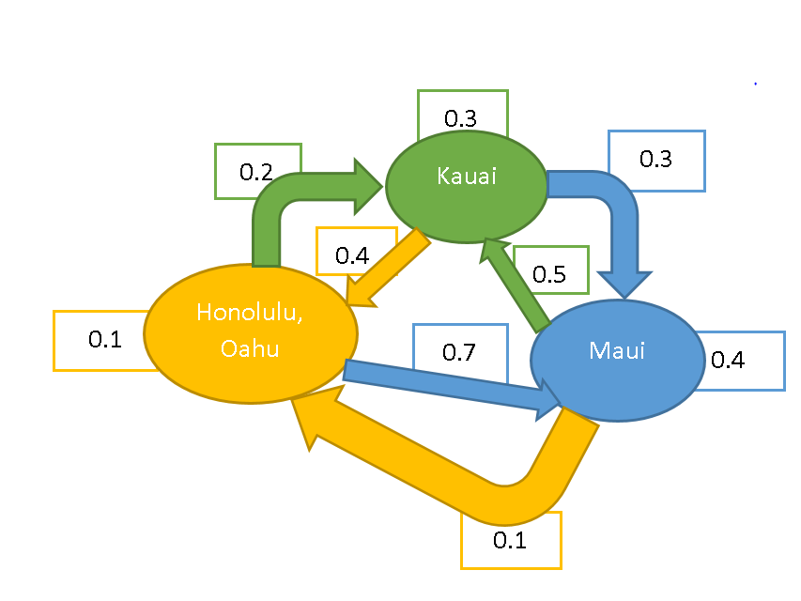

**1 Step Transition Matrix**

|  |  |  |  |
| --- | --- | --- | --- |
|  | Oahu | Kauai | Maui |
| Oahu | 0.1 | 0.2 | 0.7 |
| Kauai | 0.4 | 0.3 | 0.3 |
| Maui | 0.1 | 0.5 | 0.4 |

**3 Step Transition Matrix**

|  |  |  |  |
| --- | --- | --- | --- |
|  | Oahu | Kauai | Maui |
| Oahu | 0.229 | 0.366 | 0.405 |
| Kauai | 0.196 | 0.379 | 0.425 |
| Maui | 0.211 | 0.351 | 0.438 |

**Probability of Starting and Ending at Oahu = 0.229 = 22.9%**